FOREIGN CROATS

THE ORIGIN OF THE CROATS
According to legend, Croats immigrated under leadership of five brothers: Klukas, Lobel, Muhlo, Kosjenac, Hrvat and two sister Tuga and Buga, so it is
possible that one of the brothers called Hrvat came from the name for the Croat people. This folklore, which at the level of the narrative image may have
something to do with reality, is recorded in the significant Byzantine diplomatic manual De Adinistrando Imperio from the 10th century. Chapters 29, 30
and 31 of this work provide information that obviously better reflects the history of the Croats and their state along the Ariatic: it is learned that the Croats
came from the area north of Hungary and east of Bavaria, that after coming to the territory of today's Croatia, they accepted Christianity and only with difficulty got rid od their dependence on the poweful Franks.

ETHNIC SPACE OF CROATS
Today, the ethnic space of Croats encompasses the entire territory of Republic of Croatia, from the Dragonja River in the west in Istra to Prevlaka and the
Bay of Kotor in the southeast, and from the Sutla River in the northwest to the Danube River in the east. Then, it covers singificant parts of Bosna and
Herzegovina: Central Bosnia, Bosanska Posavina, Western Bosnia: A significant proportion of Croats live in the area of Zavalje around Biha, Sasina,
Haramine, Ljubija, Stara Rijeka and surrounding settlements between Prijedor and Sanski Most, Croats are also represented in the vicinity of Banja Luka,
Kotor Varoš and Teslić.

LIFE AND CUSTOMS
Upon arriving in their new homeland, Croats settled in the areas between the Drava and the Adriatic Sea. Given the fluctuations of the eastern border, it
cannot be determined exactly, but traces of the earlier Croatian presence can be found in the entire territory of Bosnia and Herzegovina. On the southern
Adriatic coats, the Neretva tribe formed their principality. The area of northern Croatia between the Drava and Sava known as Pannonian (today Slavonia),
in the time before King Tomislav was called Sklanvinija, and the people who inhabited it were called Sklavinima, which is certainly a variant of the name
Slavs. Over time, the Slavic language prevailed in the area; today it is not possible to know with certanity whether the warrior tribes of Croats who
apparently came to today’s Croatian territories from the territory of today’s Poland, the Czech Republic and Slovakia originated from the local Slavic
population, or who adopted the Slavic language while living there. Part of the area inhabited by Croats, Baranja and Bačka, where they were mostly
inhabited only in the 17th century by the withdrawal of the Croatian population from the area under Ottoman rule alon the river Bosna and accorfing to
some authors, must be of “Slavic” origin. To this day, they are known for river fishing and cattle breeding, from which the majority of meat food originates.
In farming, historically, they have mainly grown cereals. Mixed with Šokci, Bunjevci live, with slightly different ethnographic characteristics. In the area of
White and Red Crotian we find again a different type of Croats. Stone, sea and sun encouraged the development of olive and grape growing. The proximity
of the sea also affected the development of shipping and piracy as a from of business. It is known that even the old Nerevans, even after they were ruled by
the Kačićs in the 12th century, were a fear and trembling to the free seafaring of Dalmatian cities, especially Venice. Croats from the Adriatic coast became
famous sailors, and this is still true from them today. The people of Dubrovnik and Bokelj have a reputation as skilled sailors. The production of wine,
prosciutto and olive is significant. These are also famous specialties of the descendants of White and Red Croats.

CULTURE AND ART
Culture in Croatia is significantly marked by its centuries-old consistent immersion in European cultural trends. Certain traces of centuries-old contact with
the culture of the former Ottoman Empire, with which Croatia bordered for centuries, are present in traces of various Turkisms (eg the words "cage",
"button", "shop" and "boot" of Turkish origin), and some folklore customs in areas that were once under Turkish rule (Slavonia, Dalmatian Zagora; also among Croats in Bosnia and Herzegovina).
Istrian divorce, a document on the demarcation of municipalities and towns in Istria from 1325, which was made in versions in German, Latin and Croatian. The Croatian version is written in Glagolitic, which for centuries was the alphabet of the literary Croatian language in the areas along the northern Adriatic
In the first centuries of written history of the Croats, the main foreign influence came through the Romanized towns on the Dalmatian coast, which were under Byzantine rule and involved in Mediterranean trade. Christianity spread among the Croatian people and nobility mostly through the local clergy, who also performed worship in the vernacular. At least as early as 928, Gregory, the Croatian bishop of Nin, was removed, with the evident efforts of bishops from Romanized cities to introduce Latin worship in Croatia - as was the case in almost all of Europe at the time - Old Slavonic worship remained in Croatia until the end. 1960s. The use of the Glagolitic alphabet, both in sacral and secular use, also persisted for a very long time; In 1483, only 28 years after Guttenberg's Bible was printed, as the first printed book in history, the "Missal according to the law of the Roman court" was printed in Croatian Glagolitic.
Since the 13th century, first on the Dalmatian islands, the Croatian Cyrillic alphabet (arvatica, bosančica, hrvatkica) has been used by Croats. With the spread of printed books, however, the writing of the Croatian language in Latin gradually prevailed. The standardization of the Croatian language, with the use of Latin, was especially influenced by the work of linguist and priest Bartol Kašić, who wrote influential Croatian dictionaries and grammars, and his Roman Ritual (ritual, a book with official instructions and forms for common prayer in the church) from 1640. It was officially used in the Catholic Church until the 19th century, and had an influence on the Croats, similar to that of the 1611 King James Bible in the English - speaking area.

Picture: 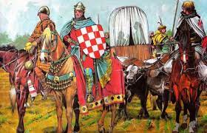-the arrival of the Croats, 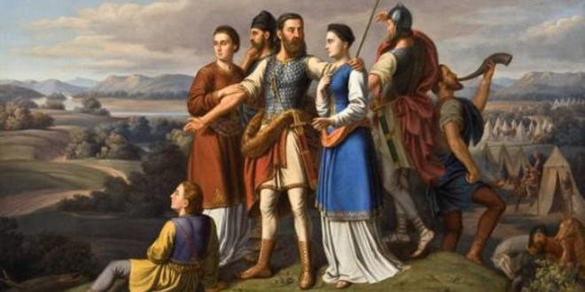-Croatian princes
Link: https://youtu.be/X_3fntSLU9w
https://youtu.be/shNbXQyp22Q
https://youtu.be/kXxJA3-gBzU
New words:
1. Leadership- vodstvo
2. Christianity- kršćanstvo
3. Represented- zastupljeni
4. Encompasses- obuhvaća
5. Surrounding settlements- okolna mjesta
6. The fluctuations of the eastern border- kolebanje istočne granice
7. Glagolitic- glagoljica
8. Area- područje
9.Specialties of the descendants- specijalnosti potomaka
10. Standardization- standarizacija

Student: DORA ŽIDAK
Class:7.N
Teacher: Matej Škaro
School years: 2020./2021.

